**Program no____10____**

**Program Title______ GAS detector_________**

**Aim to detect the presence of GAS.**

**Hardware Required**

* Arduino Board
* Gas sensor
* Led
* resistor

**Circuit Diagram**

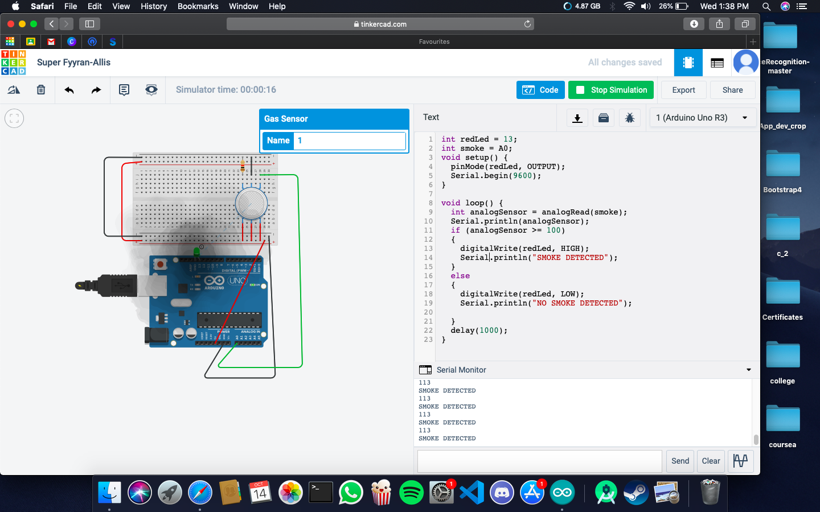

**Code:**

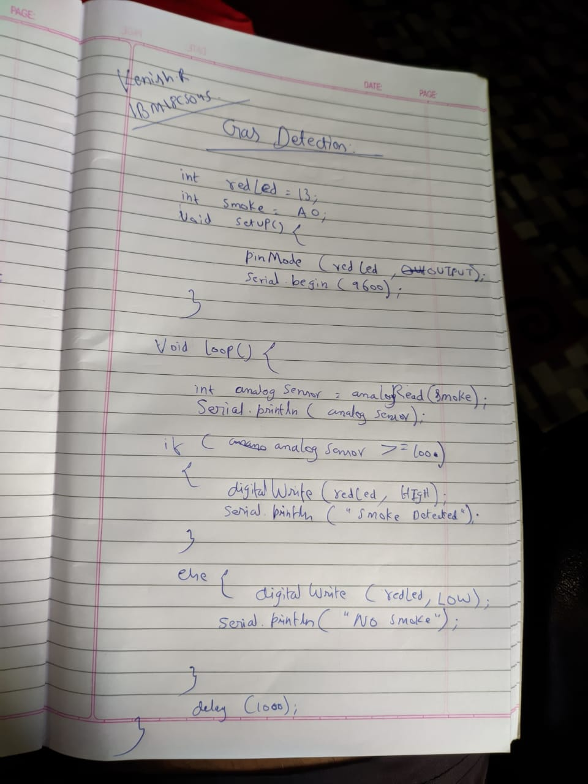

**Observation /Output**

**Gas will be detected.**